Introducing Geodesign: The Concept

William R. Miller, Esri
Director of GeoDesign Services

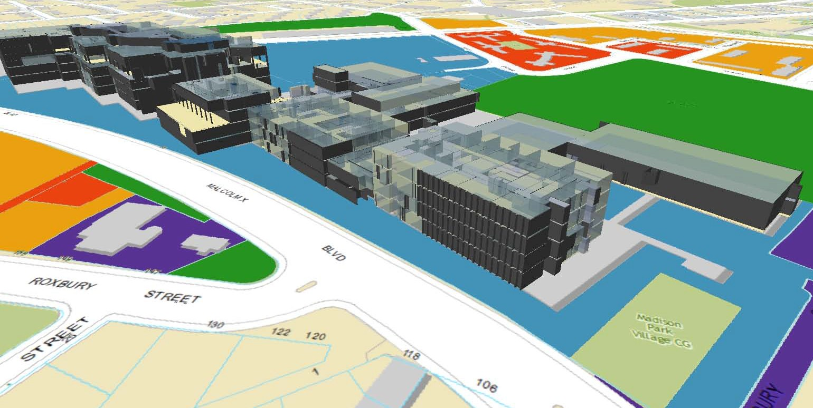

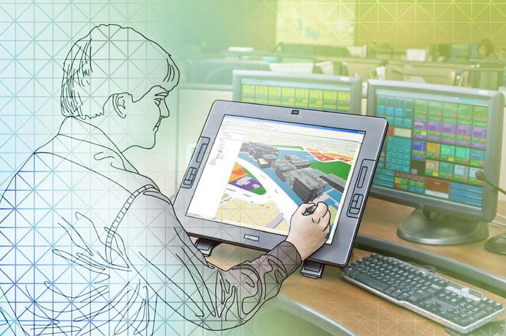

Introduction

This purpose of this paper is twofold: First, to introduce the concept of geode- sign, what it means, and some of its implications, particularly for those working with geospatial data; and Second, to encourage the reader to play an active role in the development and expansion of this nascent field.

The paper will address the following topics:

• The context for geodesign

• The history of geodesign

• Defining geodesign

• The importance of geodesign

• The nature of design

• Managing complexity

• The technology of digital geodesign

• Creating the future

Additional information regarding the subject of geodesign, including the geode- sign process, geodesign technology, and various geodesign case studies, is referenced at the end of this paper.

Cover graphic:
Provided by PenBay Solutions LLC, global leaders in facilities GIS

Graphic tablet:
Provided by Wacom®, global provider of pen tablets and interactive displays

The Context for Geodesign

Every organization, large or small, public or private, does three things: it gets and manages information (data), analyzes or assesses that information with respect to some purpose (analysis), and (based on that information and those assessments) creates or re-creates goods and/or services (design). It is, in fact, the creation or re-creation of goods and/or services that gives most organizations their reason
for being.

By and large, geographic information system (GIS) technology, as it’s known today, serves organizations quite well with respect to the need to acquire and manage geospatial information. GIS also offers organizations a wide range
of geoprocessing functions for analyzing geospatial information. While this is beginning to change, present-day GIS still offers little functionality with respect to an organization’s need to create and/or re-create goods and services, that is, its need to do design … to do geodesign.

Assuming the average organization spends a third of its operational resources on each of these three segments (data, analysis, and design), a GIS technology company (like Esri) could increase the organization’s revenue by 50 percent, with- out adding any new customers, by simply expanding its products and services to support customers’ activities related to design.

Every organization does three things: it gets and manages information (data), analyzes or assesses that information with respect to some purpose (analysis), and (based on that information and those assessments) creates
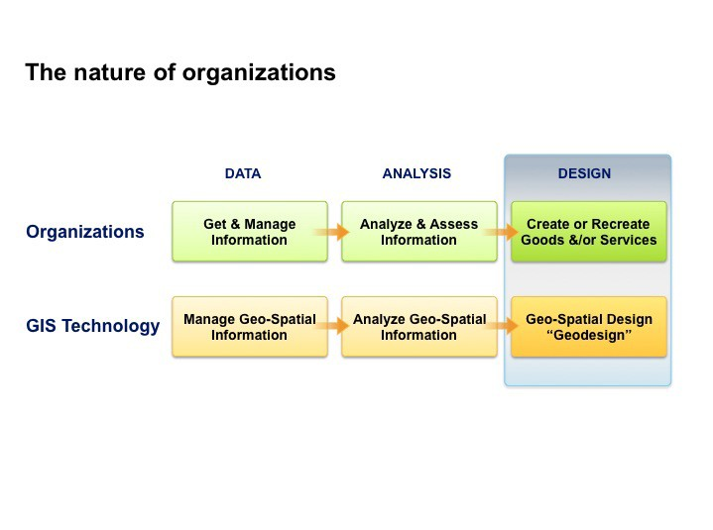or re-creates goods and/or services (design).

The History of Geodesign

The history of geodesign can be described as the emergence of geodesign as an
activity or as the emergence of the term geodesign.

Emergence of the activity
The main idea underlying the concept of geodesign, namely that the context of our geographic space conditions what and how we design (that is, how we adjust and adapt to our surroundings), has been with us since the beginning of time.

The main idea underlying the concept of geodesign, namely that the context of our geographic space conditions what and how we design
(that is, how we adjust and adapt to our surroundings), has been with us since the beginning of time.
Deciding where to locate a tribal settlement, choosing materials to use to con- struct shelters, developing a strategy for hunting wild animals, deciding where to plant crops, or laying out the plans for defending a settlement from intrud- ers are all geodesign-related activities. That is, the successful design of each
of these depends on having adequate knowledge of the relevant geographic conditions and the ability to work with those conditions, as well as respecting the constraints and taking advantage of the opportunities suggested by those conditions.

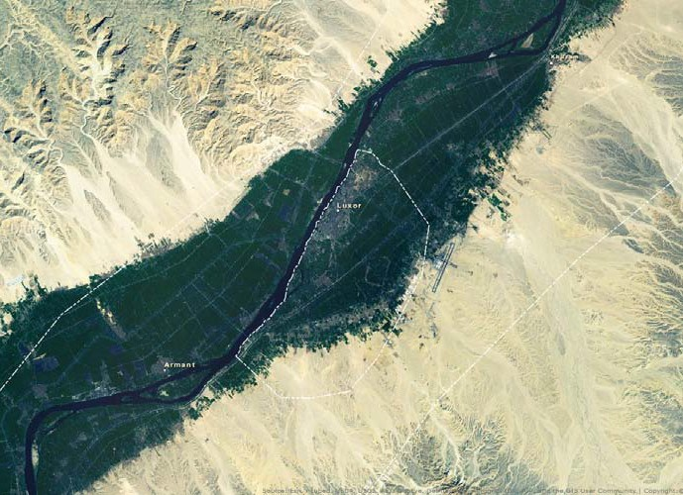
This image of Luxor, Egypt, site of the ancient Egyptian capital Thebes, shows the importance of the Nile to the sustainability of both historic and modern cities of Egypt. Herodotus alluded to the application of geodesign when he said “Egypt is truly a gift of the Nile.”

The corollary is also true: what and how we design has the power to condition or change the context of our surroundings, that is, to change our geographic space. In fact, any design-related activity that depends on or in some way changes the context of our surroundings can be considered geodesign.

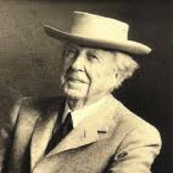Frank Lloyd Wright (1867–1959)
invoked the idea of geodesign
(though he did not use the term) when he formalized the idea of organic architecture, that is, making the struc- tures and nature one by, for instance, bringing the outdoors in (e.g., through the use of corner windows) and
moving the indoors out (e.g., through
the use of sliding glass doors).

When Wright was asked by Edgar Kaufmann Sr. to design a small vacation home on Bear Run in rural
southwestern Pennsylvania (the home later known as Fallingwater), he had been without a commission for months. He postponed working on the design to a point where many of his disciples began to wonder if he was beyond his prime and perhaps not up to the challenge. That was just about the time Kaufmann called Wright to ask how he was coming along with the design and tell Wright that he was on his way to Taliesin, Wright’s studio near Spring Green, Wisconsin. Wright responded by saying he was expecting Kaufmann’s visit and encouraged Kaufmann to come at his earliest convenience, which turned out to be about three hours.
Wright then hung up the phone and went to work on the design, his students and staff sharpening pencils as Wright feverishly worked at his drafting table, laying out the design of the house, including floor plans, elevations, sections, and a quick perspective. The basic concept was fully completed by the time Kaufmann arrived later that afternoon (Toker 2005)

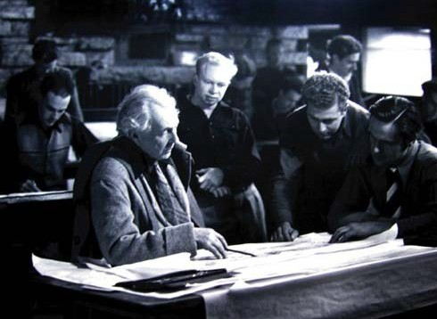Was Wright doing geodesign? The answer is, most definitely.

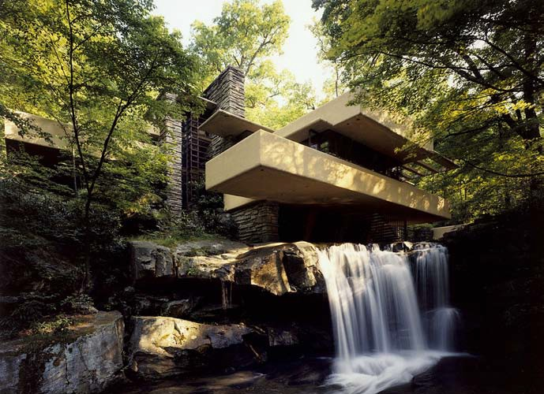
Source: Figuura.

Was Wright doing geodesign? The answer is, most definitely. Wright had the site’s geography fully in mind while he was doing the design, giving consider- ation to topography, the location of the stream and waterfall, the placement of boulders that provided the foundation for the house, views to and from the
house, and site-related environmental conditions such as the use of solar access for heating the house in the winter and cold air flow along the stream for cooling the house in the summer. Wright was most definitely doing geodesign.

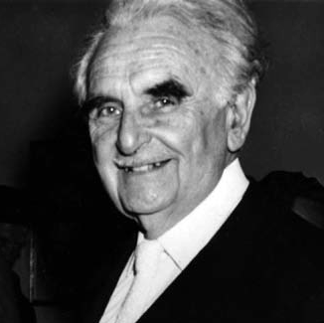Richard Neutra (1892–1970), an Austrian architect who had worked with Wright in the mid 1920s, later wrote Survival through Design, one of the pivotal books on the importance of designing with nature. In it, he advocated a holistic approach to design, giving full attention to the needs of his client while at the same time emphasizing the importance of the site, its natural conditions, and its surround- ings. Neutra’s book predated the environmental movement by 20 years and in many ways contributed to the formation of the Environmental Protection Act of
1970, the year Neutra died (Neutra 1954). Ironically he passed just a week before the first Earth Day celebration of Sunday, April 22, 1970, something that would have gladdened his heart.

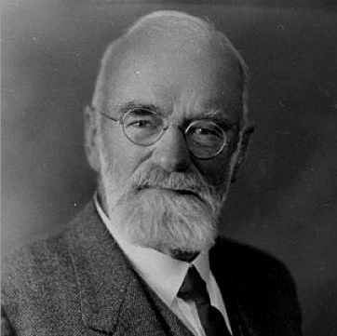Warren H. Manning (1860 –1938) worked for Frederick Law Olmsted as a horticulturalist before establishing his own landscape architecture prac- tice. By about 1910, electricity had become widespread, and light tables (drawing tables with translucent
glass tops illuminated from below) were invented, initially to simplify the tracing of drawings. In 1912, Manning made a study that used map overlays as an analysis method, much as is done today. By using overlays on a light table, he made a landscape plan
for the entire country, which was published in Landscape Architecture in June
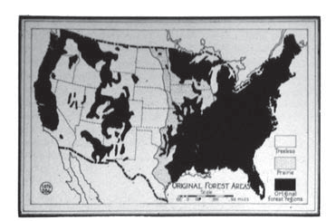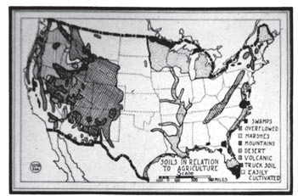1923 (Steinitz 2012).

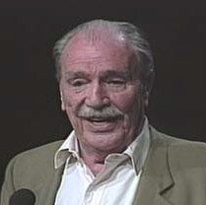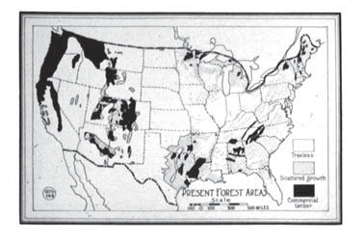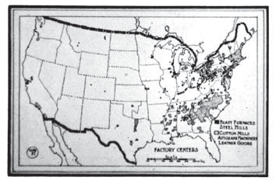Ian McHarg (1920 –2001), Scotsman, landscape architect, and educator, is without a doubt, though he never used the term, one of the principal founders of geode- sign. His 1969 book Design With Nature not only expresses the value of design- ing with nature (primarily as related to the fields of landscape architecture and regional planning) but also sets forth a geo-based technique (which was most probably based on Manning’s work), viewing and overlaying thematic layers of geographic information to assess the best (or worst) location for a particular land use (McHarg 1969).

McHarg was also one of the first to advocate a multidisciplinary approach to envi- ronmental planning, which until that time had been dominated by narrow views and singular values. Supported by a series of grants while leading the program at the University of Pennsylvania, he was able to assemble a team of scientists and

In 1912, Manning made a study that used map overlays as an analysis method, much as is done today.

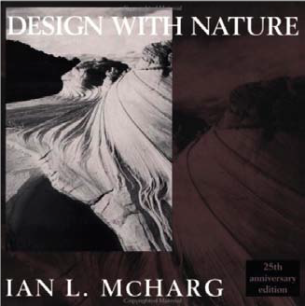experts from a wide variety of disci- plines in the physical, biological, and
social sciences (McHarg 1996).

McHarg gave birth to a whole new way of thinking about regional planning and design.

While McHarg was at the University of Pennsylvania promoting his graphical overlay technique and receiving considerable attention for his book, a
substantial body of knowledge related to environmental planning (geodesign) was
being quietly developed and accumulated by Carl Steinitz and his colleagues at the Harvard Graduate School of Design.
While McHarg’s technique was completely graphical (non-digital), his book gave birth to a whole new way of thinking about regional plan- ning and design. It not only laid out a clear procedure for assessing the
geographic context of a site or region but also presented that procedure with a clarity that quickly led to the digital representation of geographic information (as thematic layers) and
assessment strategies (e.g., using weighted overlay techniques), which, in time, contributed to the conceptual development of GIS.

It is interesting to note that while McHarg was at the University of Pennsylvania promoting his graphical overlay technique and receiving considerable attention for his book, a substantial body of knowledge related to environmental planning (geodesign) was being quietly developed and accumulated by Carl Steinitz and his colleagues at the Harvard Graduate School of Design.

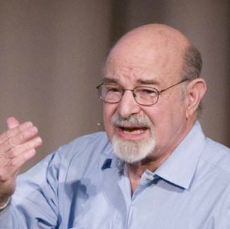Carl Steinitz (1938–), working with his colleagues and students over a period of approximately 30 years, developed a complete framework (conceptual framework, design strategies, and procedural techniques) for doing geodesign as applied to regional landscape studies. The Steinitz Framework for Geodesign (Steinitz
2012), previously called a Framework for Landscape Planning (Steinitz 1995), advocates the use of six models to describe the overall planning (geode- sign) process:

Representation Models How should the context be described? Process Models How does the context operate? Evaluation Models Is the current context working well? Change Models How might the context be altered?
Impact Models What differences might the alterations cause? Decision Models Should the context be changed?
The first three models comprise the assessment process, looking at existing conditions within a geographic context. The second three models comprise the intervention process, looking at how that context might be changed, the potential consequences of those changes, and whether the context should be changed.

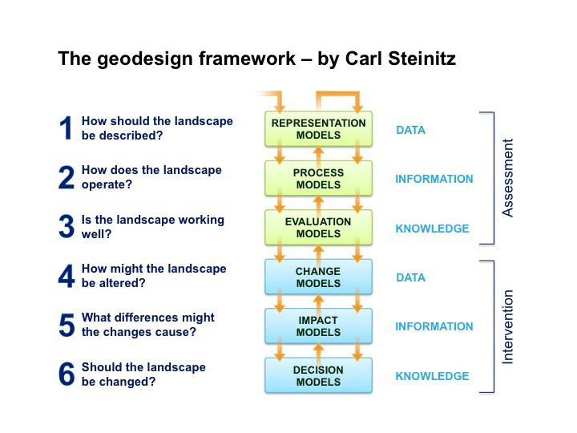Steinitz’s new book, A Framework for Geodesign, soon to be published by Esri Press, delineates the conceptual framework for doing geodesign and will surely become one of the
bibles for both practitioners and academics for years to come.

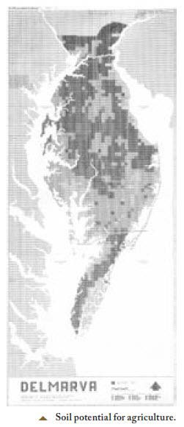The fourth model, the Change Model, provides the specific framework for devel- oping and creating proposed changes (design scenarios) that are predicated
on the science- and value-based information contained in the Representation Models and assessed against that same information in the Impact Models, which is the essence of the underlying concepts of geodesign.

Steinitz’s new book, A Framework for Geodesign, soon to be published by Esri Press, delineates the conceptual framework for doing geodesign and will surely become one of the bibles for both practitioners and academics for years to come.

While Steinitz’s foundational work was, and still is, technology independent, much of what he and his students were doing at Harvard was supplemented by the work that was going on at the Laboratory for Computer Graphics and Spatial Analysis, also at Harvard.

Howard Fisher (1903–1979) founded the Laboratory for Computer Graphics in
1965, which later became more broadly known as the Laboratory for Computer Graphics and Spatial Analysis. Fisher developed the SYMAP program, which was one of the first computer mapping programs to become widely popular with planners. The lab he founded became responsible for the further development of SYMAP, which predated and ultimately led to the development of GIS (Chris- man 2006).

Courtesy Carl Steinitz

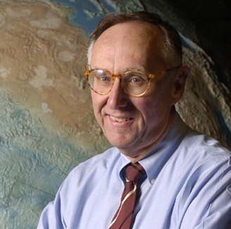Jack Dangermond (1945–), presi- dent and founder of Esri, was one
of Steinitz’s students at Harvard. He was studying landscape architecture but was also keenly interested in the work at the Laboratory for Computer Graphics and Spatial Analysis. After graduating in 1970, he used SYMAP
to start his company, which is now the
world’s leader in GIS technology.

One of Dangermond’s longtime dreams has been to use the science developed by Goodchild and others, coupled with the design framework developed by Steinitz and
his associates at Harvard, with computer technology to represent geography
(geospatial information) as a platform for doing design.
While Dangermond and his associ- ates were doing foundational work in the development of GIS technology,
seminal work was also being done with respect to the development of the sci- ence of GIS.

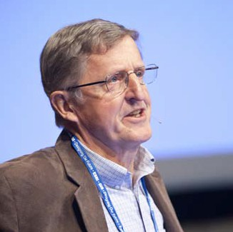Michael Goodchild (1944–), a British- American geographer, and his associ- ates and counterparts from around
the world (too many to reference here) worked over a period of 30 years to develop the science of GIS. Good- child founded the National Center for Geographic Information and Analysis (NCGIA) in 1988 and served as its director for 20 years. NCGIA became the breeding ground for research and the development of educational mate- rials supporting the science of GIS.

Goodchild, along with David Maguire and David Rind, wrote Geographical Information Systems: Principles and Applications (1991), which at the time of its publication was consider by many to be the bible of geographic information sci- ence. They later wrote, with the addition of Paul Longley, Geography Information Systems and Science (2001), which today serves as one of the standard textbooks on geographic information science.

One of Dangermond’s longtime dreams has been to use the science developed by Goodchild and others, coupled with the design framework developed by Steinitz and his associates at Harvard, with computer technology to represent geography (geospatial information) as a platform for doing design, the idea of digital geodesign and the central theme of this white paper.

Given this sequence, it is easy to see that the activity of geodesign (as opposed to the term geodesign) has been around for quite some time, one could argue since the beginning of mankind. As a consequence, one might ask, “What’s the big deal?”

In many respects, there is no “big deal.” The idea of geodesign is not new. The big deal comes not from the fact that geodesign is new but rather from the formalization of the ideas surrounding geodesign, such as those initiated by McHarg and later developed by Steinitz, and how those ideas, coupled with the work of Fisher, Dangermond, and others, now give us the power to use GIS as a
framework for doing geodesign in digital geographic space.

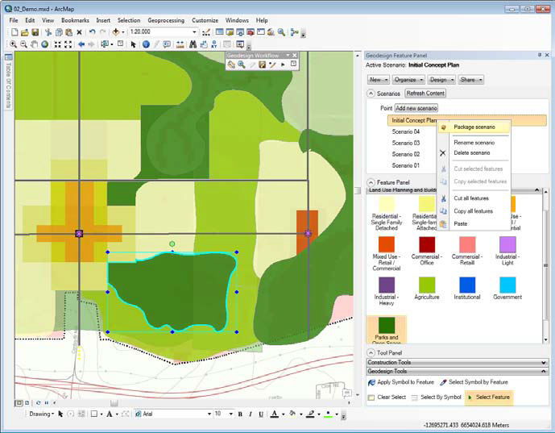
A new geodesign tool for creating, managing, and populating scenarios in ArcGIS depicts one
of O2 Planning + Design's sketched land-use scenarios for the Nose Creek Watershed in Alberta. (Image courtesy of O2 Planning + Design; Map data courtesy of GeoBase)

“I turned to Jack and said,
‘See, Jack, now you can design in geographic space.’ Without hesitation, Jack said,
‘Geodesign!’”

Emergence of the term

The term geodesign, unlike the activity of geodesign, is relatively new. Klaus Kunzmann provides an early reference to geodesign in his paper, “Geodesign: Chance oder Gefahr?” (1993). He used the term to refer to spatial scenarios. Since then, a small number of geo-related businesses have used geodesign as part of their name.

In approximately 2005, Dangermond and a few others were observing a demo at Esri showing how users could sketch land-use plans in GIS using an extension we had developed for ArcGIS® called ArcSketch™. One of the members of our team was sketching in points, lines and polygons, all defined and rendered to repre- sent various types of land use, when “I turned to Jack and said, ‘See, Jack, now you can design in geographic space.’ Without hesitation, Jack said, ‘Geodesign!’” (Miller 2011). The term stuck and soon became the moniker for Esri’s agenda for supporting the needs of designers working in a geospatial environment. More broadly, it has also become the moniker for a whole new wave of thinking regard- ing the use of GIS as geographic frame work for design.

Defining Geodesign

Before proceeding, however, a little deeper look at what is meant when using the term geodesign will be beneficial, particularly as it relates to Esri’s agenda
for supporting designers. The definition of geodesign is derived from two terms, geo and design. Both of these component terms are subject to a wide variety of interpretations. As such, they need to be clearly defined before attempting to
define geodesign.

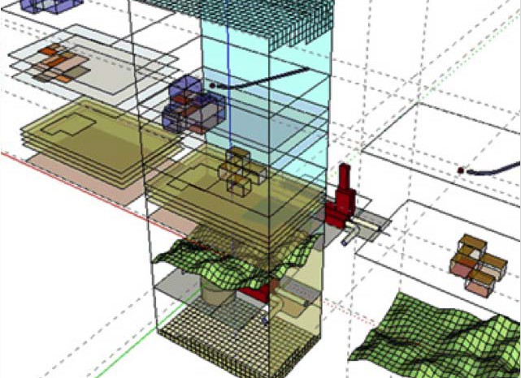These extended views of geographic space (moving from 2D to 3D to 4D), coupled with the idea that most data, at some level, is spatial and that all types of spatial data (physical, biological, social, cultural, economic, urban,
etc.) can be geo-referenced, lead to an expanded view of what is typically envisioned, or imagined, when referring to the geo portion of geodesign.

Defining Geo

The term geo can be simply defined as geographic space – space that is ref- erenced to the surface of the earth (geo-referenced). In general, thinking of geographic space brings to mind a 2D geographic space (a flat map) or, for those who are a bit more advanced in their thinking, a 2.5D geographic space – that
is, an undulating surface (a relief map). This thinking could also be extended to include 3D geographic space, providing the ability to geo-reference what lies below, on and above the surface of the earth, including what exists inside and outside buildings, as well as 4D geographic space, giving the added ability to geo-reference time-dependent information such as population growth or the migration of a toxic plume through a building.

These extended views of geographic space (moving from 2D to 3D to 4D), coupled with the idea that most data, at some level, is spatial and that all types of spatial data (physical, biological, social, cultural, economic, urban, etc.) can be geo-referenced, lead to an expanded view of what is typically envisioned, or imagined, when referring to the geo portion of geodesign. This expanded view
is embodied in a new concept that is beginning to emerge within the geospatial community … that of geo-scape.

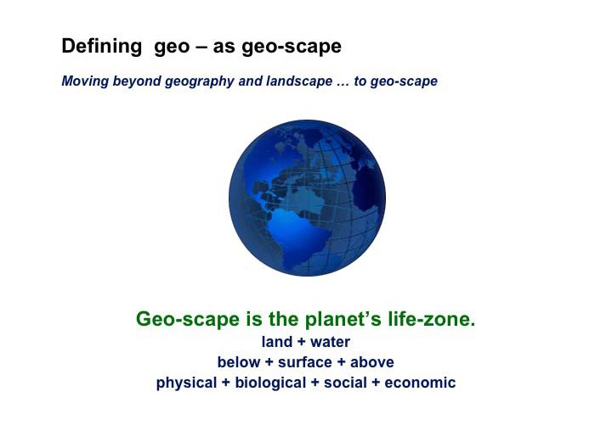Geo-scape is the planet’s life zone, including everything that lies below, on, and above the surface of the earth that supports life. Geo-scape expands the view of what constitutes the content of geography as well as the dimensional extent of the geographic space used to reference that content. As a consequence, it also expands the domain of geo in geodesign to include everything that supports or inhibits life (Miller 2004).
Geo in geodesign thus refers to the full spectrum of the earth’s life support system and extends thinking to move from

Land | → | Land, water, air
Surface | → | Below, on, above the surface
2D/2.5D | → | 3D/4D
Rural | → | Rural and urban
Outside buildings | → | Outside and inside buildings
Objects | → | Objects, events, concepts, and relationships
Each of these moves represents a significant transformation in the way people think about geography, geodesign and the use of GIS.

Defining Design

The word design, the second component of geodesign, can be defined as either a noun or a verb. As a noun, design generally refers to some object or other entity. As a verb, it usually refers to a process or series of activities.

“Design is the thought process comprising the creation of an entity” (Miller 2005).

It is first thought, or the type of thought called insight. It is the mental synapse that instantly sees the potential connection between problem and possibility, the capacity for order in the midst of chaos or for improvement amid inefficiency.

Geo-scape is the planet’s life zone, including everything that lies below, on, and above the surface of the earth that supports life.

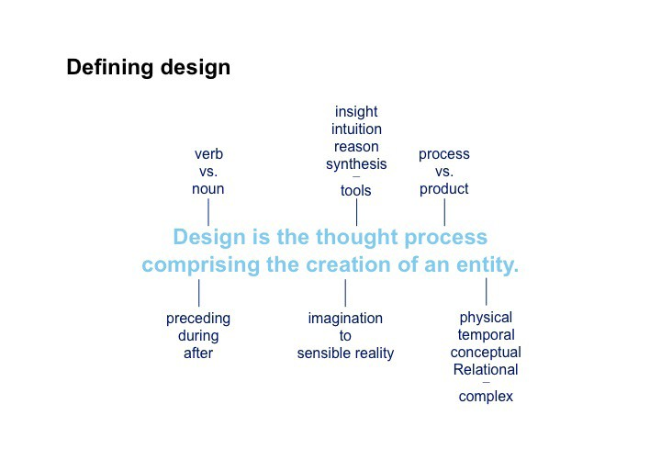Design is the thought process comprising the creation of an entity.

An entity can be an object that occupies space, an event that occurs in time, a concept (such as the theory of relativity), or
a relationship (such as a treaty between nations).
Design is also intuition, that form of subconscious thought that leads to a deeper sense of knowing, often in the apparent absence of rational confirmation. Intu- ition is akin to an elongated insight that tells us we are on to something. It is the hunch that often underlies efforts to perform rational analysis.

The nature of this process, which is often modeled as a linear sequence of events, is in reality a highly complex, multifaceted set of thought-filled activities. While design is linear in the sense that it is sequenced in time as one moves from initial concept to a completed product, it is also nonlinear. Design thought often jumps in discontinuous steps from one aspect of a problem to another as it searches
for a solution. It is also multileveled in the sense that overall systems, subsystems, and even minute details often need to be considered simultaneously.

This comprehensive thought-filled process is directed toward and culminates in creation. That is, it leads to the tangible realization of an entity (the thing being designed) in time and space. An entity can be an object that occupies space, an event that occurs in time, a concept (such as the theory of relativity), or a relation- ship (such as a treaty between nations). Most entities are complex in that they contain two or more of these entity types.

Any entity can be designed or created with intent and purpose. The total thought process encompassing the creation of that entity – the process that gives it its form, be it physical, temporal, conceptual, or relational – is design.

Defining the Purpose of Design

It is important to note that the preceding definition of design does not define, or in any way describe, what constitutes good design.

The ethic of design, that is, how a design (noun) is determined to be good or bad comes not from the definition but rather from the purpose of design, which at a fundamental level is always the same.

“The purpose of design is to facilitate life” (Miller 2006).

Simply put, if an entity (the thing being designed) facilitates life, then it is good; if it inhibits life, it is bad; and if it does neither, it is neutral. While this is a very simple ethic, or appears as such at first glance, one must constantly remember two things: what it means to facilitate and what is meant by life.

The word facilitate means to empower, enable, or assist, but not dictate, as was sometimes assumed by the utopian designers of the early 20th century. Utopian design, based on the notion that the designer knows what is best, is really dicta- torial design and is often a form of imprisonment in that it shackles its users to a particular behavior pattern or singular point of view. The purpose of good design is not to imprison but rather to enrich (that is, to facilitate) the lives of those using the design (noun).

Fritjof Capra, author of The Web of Life, describes four aspects of life (Capra 1996), First, all living systems are open systems. Second, all living systems are interde- pendent systems. Third, all living systems are self-organizing. And fourth, all living systems make use of some form of feedback (loops, networks, webs) to manage themselves.

Open systems require the input of an energy source, for example, food, oxygen, and sunlight to sustain themselves. They also produce output that if it can be used by another living system, is called product; if not, it is called waste. It is important to acknowledge that all living systems are open and require a continu- ous input of resources and that they constantly produce some type of output.

As such, living systems are neither independent nor dependent systems but rather interdependent systems that rely on neighboring systems for their survival, supplying their input and processing their output. Carrying these links forward,
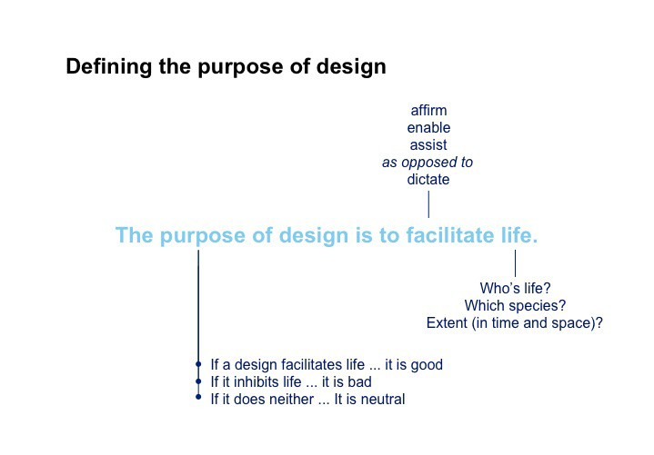it is not difficult to see that all living systems are interdependent in one way or another with all other living systems.

The ethic of design, that is, how a design (noun) is determined to be good or bad comes not from the definition but rather from the purpose of design, which at a fundamental level is always the same.

The purpose of design is to facilitate life.

Consequently, the question that really must be asked is, “Whose life?”

Consequently, the question that really must be asked is, “Whose life?”

The answers to these questions for a given project form the design ethic for
that project and, in so doing, provide the ability to assess the goodness of the design (noun).
Are we talking about the life of the designer or the design team? The lives of those commissioning the creation (design) of an entity? The lives of those des- tined to use the entity? Or the lives of those affected by the use of the entity? Human life? The life of a particular species, or life in general? The question of whose life to facilitate, over what period of time, and to what extent, is very important and often leads to unexpected complexity.

The answers to these questions are not simple, surely not singular, and often not static. In many cases, both the questions and answers, as related to a particular entity, change over time. While this complexity, as it intensifies, has the potential to give one pause, or even overwhelm, it is always important to remember the simplicity of the original statement of purpose – that the purpose of design is to facilitate life. This serves as the foundation for the fundamental question to ask regarding the purpose of the entity being designed.

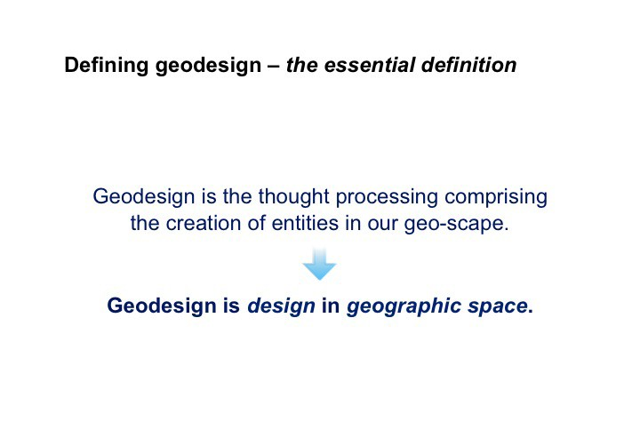The answers to these questions for a given project form the design ethic for that project and, in so doing, provide the ability to assess the goodness of the design (noun).

Defining Geodesign

Given the new definitions of geo and design, they can now be combined to form a definition of geodesign:

Geodesign is the thought process comprising the creation of an entity in the planet’s life zone (geo-scape).

Or, more simply, geodesign is design in geographic space (geo-scape). Cor- respondingly, the purpose of geodesign is to facilitate life in geographic space (geo-scape).

The essential aspect of this definition is the idea that design – the process of designing (creating or modifying) some portion or aspect of the environment, be it natural or man-made – occurs within the context of geographic space (where the location of the entity being created is referenced to a geographic coordinate system) as opposed to conceptual space (creating something in the imagination with no locational reference), paper space (creating something with pencil and paper, again with no locational reference), or even CAD space (where the enti- ties in that space are referenced to a virtual coordinate system as opposed to a geographic coordinate system).

At first glance, this seems to be a trivial point. However, the fact that the entity being created or modified is referenced to the geographic space in which it resides means that it is also, either directly or indirectly, referenced to all other information referenced to that space. This means that the designer can take advantage of, or be informed by, that information and how it relates to or condi- tions the quality or efficiency of the entity being designed, either as it is being designed or after the design has matured to some point where the designer wishes to perform a more comprehensive assessment.

The Importance of Geodesign

This referential link between the entity being designed and its geographic con- text provides the tangible basis for doing both science-based and value-based design. Additionally, it has the ability to provide operational linkages to a wide variety of domain-specific information and, in so doing, provides the multidisci- plinary platform for doing integral design (holistic design).

The essential aspect of this definition is the idea that design – the process of designing (creating or
modifying) some portion or aspect of the environment, be it natural or man-made – occurs within the context of geographic space.

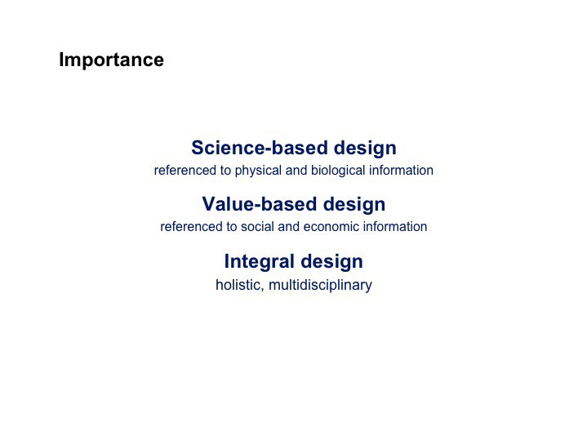The fact that the entity
being created or modified is referenced to the geographic space in which it resides means that it is also, either directly
or indirectly, referenced to all other information referenced to that space.

Geodesign not only provides the ability to link the entity being designed to relevant science- and value-based information, but also provides the framework for exploring issues from an interdisciplinary point of view and resolving conflicts between alternative value sets.

Design (the process of designing something) is, in general, not well understood.
Science-Based Design

Science-based design is the creation or modification of an entity within the context of scientific information (including scientific processes and relationships) such that the design of the entity is conditioned or informed by that science as it is being designed. Geodesign, through the use of a common geographic refer- ence system, provides the ability to link geographic entities (those entities that are being designed) to scientific information, relevant to the creation, instantia- tion, or utilization of those entities.

Value-Based Design

Value-based design is the creation or modification of an entity within the context of social values (global, community, cultural, religious, etc.) such that the design of the entity is conditioned or informed by those values as it is being designed. As is the case with science-based design, geodesign provides the ability to link geographic entities (those entities that are being designed) to social values rel-
evant to the creation, instantiation, or utilization of those entities, assuming those values are referenced to the same geographic reference system.

Integral Design

Geodesign not only provides the ability to link the entity being designed to relevant science- and value-based information, but also provides the framework for exploring issues from an interdisciplinary point of view and resolving conflicts between alternative value sets. In this sense, it can be seen as an integral frame- work for intelligent, holistic geospatial design.

The important point to note, however, is that the act or process of design occurs in geographic space where the entity being designed is geo-referenced to a common geographic coordinate system and, thus, directly or indirectly to other information that is also referenced to that system. This referential link between the entity being designed and information (be it science-based or value-based)
gives the designer the ability to design within the context of that information and, in so doing, improve the quality and efficiency of the design process as well as that of the entity (the product of that process).

The Nature of Design

Design (the process of designing something) is, in general, not well understood. While most people, particularly those working with GIS, can understand the
value or importance of geodesign as described in the previous section, relatively few have been trained in design and lack, at least to some degree, an apprecia- tion of the nature of design and the way designers think and work.

While the responsibility for fully describing the nature of design and all its idio- syncrasies lies beyond the scope of this paper, it will be helpful to understand three characteristics that are fundamental to most design activities: abductive thinking, rapid iteration, and collaboration.

Abductive Thinking

Abductive thinking is an extension of classical Aristotelian logic, moving beyond what can be logically induced (bottom-up thinking) and/or what can be logically deduced (top-down thinking) to what might be hypothesized, guessed, or imag- ined beyond what is logical.

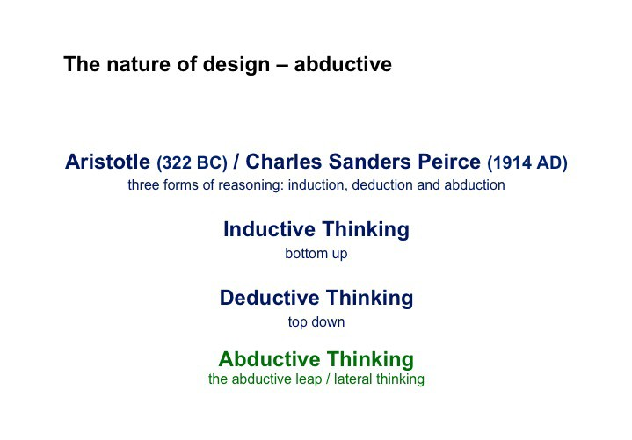Abductive thinking goes beyond logic to that reasoned edge where designers are challenged to, at one end of the spectrum, make their best guess or, at the other end of the spectrum, wildly imagine a possibility beyond reasoned assump- tion. They are challenged to take that abductive leap and, in so doing, learn from the perceived consequences of that leap.

The nature of design is all about this type of reasoning (or nonreasoning). It is about leaping beyond reason or beyond what might seem reasonable to unfore- seen possibilities. As such, while many design decisions and design-related actions are unpredictable, they can often lead to highly vital solutions.

Rapid Iteration

Design thinking is an iterative process that occurs rapidly, with little patience for context management. It occurs spontaneously. It does not tolerate interruption or diversion and is best supported by tools that require no attention during their use. Designers want to go from the figment of their imagination to some rendi- tion of that imagination with zero impedance.

Design thinking is also exploratory – it is not afraid to try something lacking reasonable support or a preestablished schema. In this sense, it is also highly unpredictable and resists being constrained or inhibited by a particular workflow.

This does not mean, however, that designers are illogical or irrational. Designers are often guided by logical thought processes. However, those processes are

Abductive thinking is
an extension of classical Aristotelian logic, moving beyond what can be logically induced (bottom-up thinking) and/or what can be logically deduced (top-down thinking)
to what might be hypothesized, guessed, or imagined beyond what is logical.

Design thinking is an iterative process that occurs rapidly, with little patience for context management. It does not tolerate interruption or
diversion and is best supported by tools that require no attention during their use.

typically more abductive by nature than they are strictly logical. They are based more on logical inference (abductive reasoning or making a reasoned guess) than they are on inductive or deductive determinism.
This means that designers want to be free to explore and express their ideas, whatever their basis, with as little resistance as possible. Additionally, they then want to be able to quickly revisit, or make another exploration, each time learn- ing from the results of their exploration.

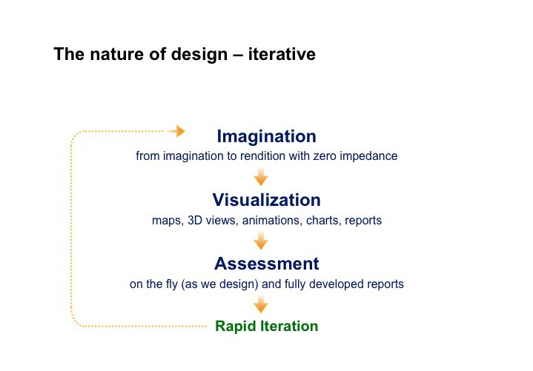Designers want to be free
to explore and express their ideas, whatever their basis, with as little resistance as possible.

Collaboration

The third aspect concerning the nature of design is collaboration. While this may seem by most people to be an obvious functional component of design, indigenous to the design process and the nature of design, to those trained as professional designers – particularly to those trained to see design as an art – it can be an oxymoron.

In truth, however, even to those imbued with the idea that design is a singular activity, most projects – particularly those involving input from many disciplines and design-related professionals – require and could not be accomplished with- out a high degree of collaboration.

Collaboration of this type involves sharing predesign considerations, ideas, strategies, proposed solutions, assessments, and implementation strategies in
a distributed time-space environment. The idea that all involved in the develop- ment of a valued design solution for any given project can meet at the same time and in the same space, repeatedly over the life of a project, is rarely valid.

The ability to effectively collaborate, and the tools supporting that collaboration
– particularly for larger, more complex projects – become the tools that can make or break the success of a project.

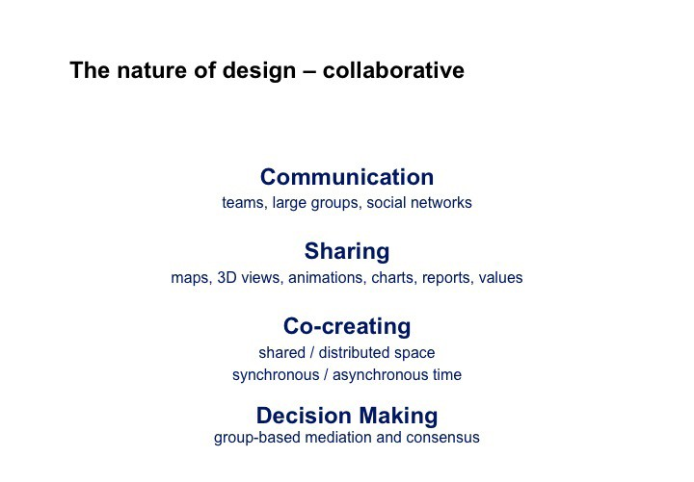The advantage of the digital approach to geodesign, particularly when one is using GIS, is that it can handle a wide spectrum of spatial complexity.

Managing Complexity

While the ability to relate an entity to its geographic context can be performed in mental space, as Frank Lloyd Wright did when he designed Fallingwater, the quality and quantity of those relationships are limited to what the human mind can reasonably hold (remember) and manipulate.

Many years ago, Princeton psychologist George A. Miller wrote a paper titled “The Magic Number Seven Plus or Minus Two: Some Limits on Our Capacity for Processing Information” (Miller 1956). What Miller basically said was that an aver- age person could keep track of seven things in their mind at once. One who was really smart could handle nine. One not so bright could probably handle five.

The reason pencil and paper are so popular is because they extend the ability to explore, assess, manage, and record the information in the mind. As a conse- quence of their use, people are able to extend their thinking and even pass it
on to others. The pencil-and-paper approach, however, as is the case with the mental approach, reasonably limits the number of factors that can be considered simultaneously. It is also a passive environment in that it performs no analysis (other than what occurs in the mind of the designer). The advantage of paper and pencil, however, is that the tools are both historically and intuitively familiar and, as a consequence, extremely easy to use. The disadvantage is that their utility diminishes as the degree of problem complexity increases.

The advantage of the digital approach to geodesign, particularly when one is using GIS, is that it can handle a wide spectrum of spatial complexity. Its dis- advantage is that the digital tools, given today’s technology, are non-intuitive and relatively difficult to use. The challenge with respect to the development of useful geodesign technology is not only the identification of what tools need to be developed but also the development of those tools so they are easy to use –
as easy, it can be said, as using pencil and paper.

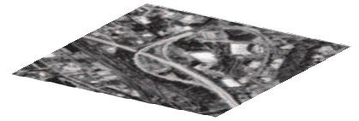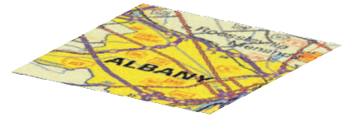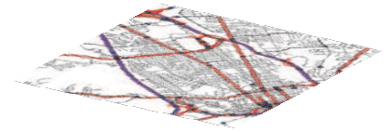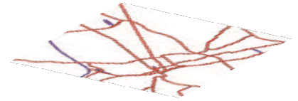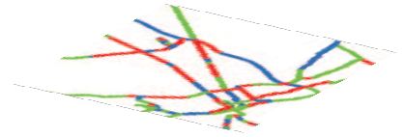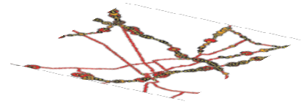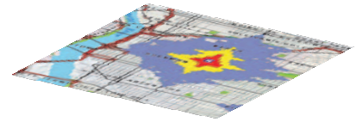The thematic layers

The advantage of a digital environment for doing geodesign can only be realized if that environment is readily accessible and easy to operate and affords the designer the ability to leverage it as an integral component of the geodesign workflow.
Layer Navigation
Map use For routing, navigation, and logistics
Data source Basemap features plus navigation properties
Representation Edges, transfers, turns, travel costs
Spatial relationships Topology networks, share geometry with routes and base maps
Map scale and accuracy Typical map scales range from 1:24 000 to 1:250 000
Symbology and annotation Varies with the source data product

Layer Point events
Map use Display and analyze DOT assets, activities, and incidents
Data source Department of Transportation departmental systems
Representation Linear-referenced point events
Spatial relationships Point events occur along routes
Map scale and accuracy Based on route geometry and measures
Symbology and annotation Typically drawn as circles colored by single attribute

Layer Line events
Map use Display and analyze DOT assets, activities, and incidents
Data source Department of Transportation departmental systems
Representation Linear-referenced line events
Spatial relationships Line events are coincident with routes
Map scale and accuracy Based on route geometry and measures
Symbology and annotation Typically drawn as thick lines colored by single attribute

Layer Routes
Map use Used to display events on DOT maintained roads
Data source State Department of Transportation
Representation Polylines with measures
Spatial relationships Should share geometry with base maps and navigation
Map scale and accuracy Typical map scales range from 1:24 000 to 1:250 000
Symbology and annotation Typically drawn as thick lines colored by single attribute

Layer Reference layer
Map use A common underlying geometry for all transportation users
Data source Multiple agencies, could be a national dataset
Representation Lines and points
Spatial relationships Could share geometry with routes
Map scale and accuracy Typical map scales range from 1:24 000 to 1:250 000
Symbology and annotation Simple gray lines as background reference

Layer Basemap
Map use Map background
Data source Topographic maps and other cartographic data sources
Representation Raster or vector maps
Spatial relationships Should share geometry with routes and navigation
Map scale and accuracy Typical map scales range from 1:24 000 to 1:250 000
Symbology and annotation Detailed transportation symbolized by class such as bridges, overpasses

Layer Digital orthophoto
Map use Map background
Data source Aerial photogrammetry and satellite sources
Representation Raster
Spatial relationships Raster cells cover the image area
Map scale and accuracy 1 to 2.5 meter cell size
Symbology and annotation Tone, contrast, and balance of gray scale or color presentation

The Technology of Digital Geodesign

The advantage of a digital environment for doing geodesign can only be realized if that environment is readily accessible and easy to operate and affords the designer the ability to leverage it as an integral component of the geodesign workflow.
While the essential aspect of geodesign lies in the fact that it is predicated on the ability to design (create entities) in geographic space, there are a number of other aspects, or characteristics, that make up the entourage of concepts and capabilities now associate with geodesign. These include the following:

Operational Framework

From an application perspective, an operational framework includes everything the user sees and touches, including hardware (display screens, keyboards, mice, touch screens, styluses, audio devices, interactive tables, tablets, and cell phones) and software (operating systems, application environments, user inter- faces, and web-related services).

An operational framework designed to facilitate geodesign needs to provide the user with use patterns that are generally consistent across all supported devices, given the functionality of the device, and provide a software environment that is intuitive and transparent, as well as one that easily supports the functional aspects and workflows associated with each of the characteristics described below.

An operational framework designed to facilitate geodesign needs to provide the user with use patterns that are generally consistent across all supported devices and provide a software environment that is intuitive and transparent.

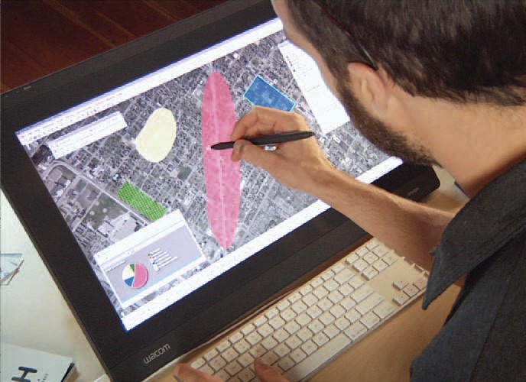(Photo copyright © Wacom)

Data Models

Data models are used to describe entity geometry, attributes, and relationships with respect to how they are defined from a user perspective, which is often domain spe- cific, and how they are structured within the context of a relational database. Most entities, such as a stream or a lake, are represented in the database using standard feature types (e.g., points, lines, polygons, rasters).

Most of the feature types referenced in a GIS are predicated on two-dimensional geospatial geometry, and while they offer the user a powerful and efficient way
to represent domain-specific information (using domain-specific data models) in
2D space, they are limited when it comes to representing and analyzing 3D enti- ties, particularly those associated with urban environments such as buildings and other forms of civil infrastructure.

In general, these tools need to be designed to support greater ease of use, giving them the ability to successfully compete with pencil and paper.
Creation and Modification Tools

There are three types of feature creation and modification tools: geometry tools that allow the user to create, replicate, and modify feature geometry; attribute tools that allow the user to assign meaning to the feature; and symbology tools that allow the user to render that feature with cartographic representations that are visually meaningful.
While these tools exist in GIS software, they have been designed to support careful feature editing with respect to the integrity of a well-structured geoda- tabase as opposed to the rapid creation of features generated by a designer. In general, these tools need to be designed to support greater ease of use, giving them the ability to successfully compete with pencil and paper.

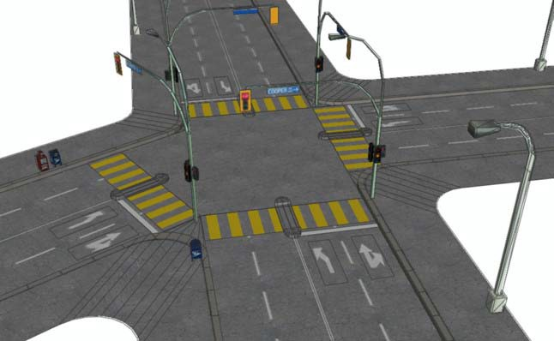Esri CityEngine technology created this rendering of a fictional intersection, demonstrating the power of rule-based 3D modeling.

Inference Engines

Inference engines are used to make assumptions based on the implied intent of the user. For example, if the user is drawing a line that is nearly parallel to the
x-axis, the inference engine might assume that it is the user’s intent to make that line parallel to the x-axis. This being the case, the inference engine would condi- tion the specification of that line so it was indeed parallel to the x-axis.
There are many types of inference engines: geometry engines, such as the one alluded to in the previous example (SketchUp® uses an inference engine of this type to aid in the creation of rectilinear geometry); topology engines used to maintain topological integrity; referential engines used to position features with respect to other features (snapping); and domain-specific engines (used to force compliance with domain-specific standards).

While it is possible to program inferred behavior responsive to some of the generic functions related to data creation, it is less so with respect to the specification of inferred behavior associated with domain-specific functions. For example, it would be relatively easy to create a tool to aid the user when drawing a line intended to
be parallel to a previously drawn line. It would be more difficult, however, to create a tool that would interpret the cross-sectional characteristics of a line representing a street centerline, not because the programming is difficult but because it is dif- ficult to know the specific characteristics of the street cross section and how those characteristics change when that line meets another line.

What one really needs is an authoring environment that allows users to create their own domain-specific inference engines, perhaps similar to the behavior of rule-based authoring environments for creating expert systems.

Visualization Tools

Visualization tools (screen displays, map viewers, video viewers, and even tools for displaying reports) are one of the most important components of a geode- sign system. The inability to visualize geospatial data, processes, assessments, plans and evaluations greatly reduces the effectiveness of the system. The need to visualize all this information is further complicated by the fact that the GIS (the predominate technology supporting the geodesign workflow) is moving to the Internet. It is even further complicated by the fact that the access points to this information are expanding to include a wide range of hardware devices (desk- tops, laptops, tablets, hybrids, and cell phones).

The form factor and capabilities of each of these devices affords the user, and the supporting information system, its own set of capabilities and limitations.
The dominate capabilities are centered on the fact that most of these devices are designed for the consumer, as opposed to the GIS professional, and are conse- quently very easy to use. Limitations are often associated with the specific char- acteristics of the device, such its size, operating system, and supported graphic formats. The fact that some devices can support graphics in one format but not another is a severe limitation, particularly if the application developer favors a more restrictive development language.

Inference engines are used to make assumptions based on the implied intent of the user.

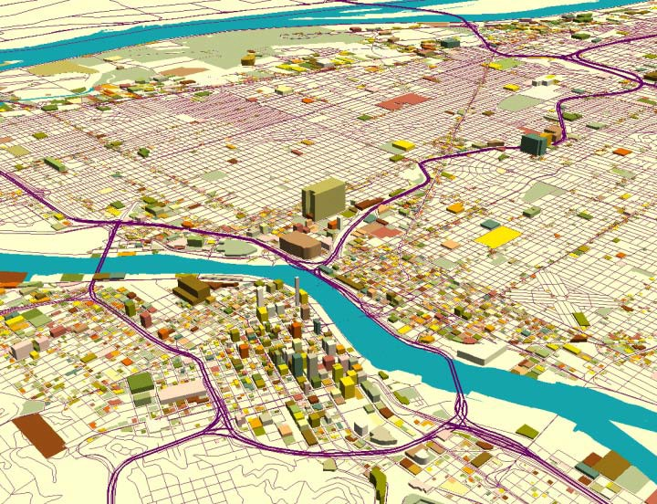

Additionally, some of the devices are read-only centric, restricting human inter- action to function selection and limited key-pad input. Others are designed to support more extensive input (e.g. sketching) but are often limited by a degree of accuracy normally associated with finger painting. Screen size, resolution, and sensitivity also play a role in creating, or contributing to, the device’s capabilities and limitations.

All of these limitations are further compounded by the emergence of cloud com- puting, Internet based GIS, and the need to develop a range of device depen- dent applications. These activities have consumed a great deal of development talent … to a point where some of the basic needs of the user, related to the visualization of geospatial data, are not being met.

For example, having the ability to create and visualize 3D objects using desktop applications but not being able to display (visualize) those same objects in view- ers designed for the Internet is a severe limitation for most users. The challenge to software developers is to create display capabilities that render geospatial information across the full spectrum of devices and operating systems.

Geoprocessing Tools

Geoprocessing tools (models and scripts) are most typically used to generate derived data from one or more geospatial datasets. One of the most powerful features of a geoprocessing model is that the output from one function can be the input to a subsequent function.
With respect to doing geospatial analysis, geoprocessing models are often used to assess the geospatial context of a study area with respect to the area’s suitability for, or vulnerability to, a particular set of land uses or land-use manage- ment strategies. They can also be used to create impact models designed to assess the probable impacts of the proposed changes.

While the geoprocessing environment in GIS software is very powerful, it has been designed primarily to accommodate geospatial analysis in 2D space as opposed to 3D space.

Additionally, while there are some workarounds in this area, the geoprocessing environment has not been designed to support geospatial simulations (discrete event-based simulation, continuous simulation, or agent-based modeling).

What one really needs is an authoring environment that allows users to create their own domain-specific inference engines, perhaps similar to
the behavior of rule-based authoring environments for creating expert systems.

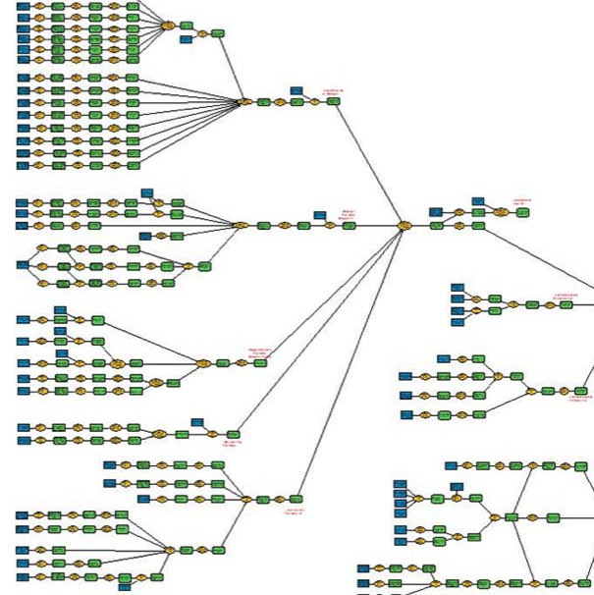Example of a series of linked geoprocessing models built using ArcGIS Model Builder. Courtesy Jones & Jones Architects and Landscape Architects, Ltd.

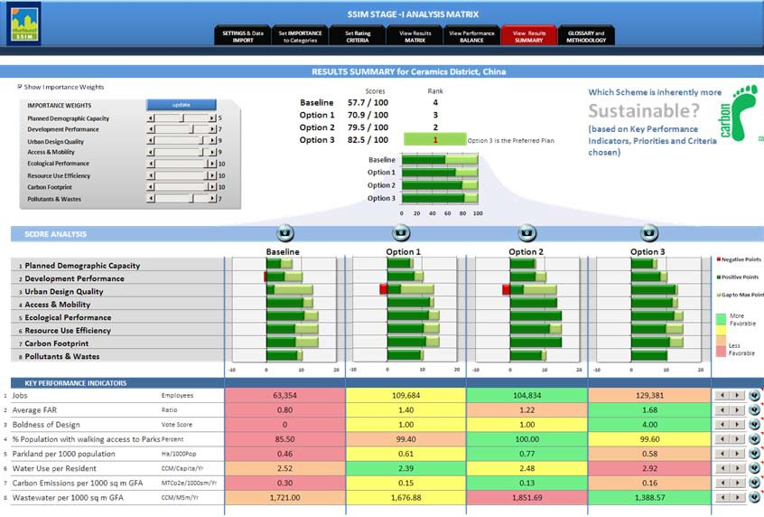Metaphorically, dashboards can be as simple as a single bar chart or as complicated as the control panel of an airplane.

Sustainable Systems Integration Model (SSIM) is a key component of AECOM’s sustainability planning process which uses dashboards to compare alternative design plans against a number of sustainability metrics. (Figure © 2011 AECOM. All Rights Reserved)

Feedback Displays and Dashboards
Geoprocessing models produce two types of output: geographic displays (usually viewed as maps) and scalar values (such as the area of a polygon or the summed area of a set of polygons), which can be used to derive various types of performance indicators. Feedback displays, often referred to as dashboards, are often used to calculate and display those performance indicators.

It is thus virtually impossible to predict the content of a dashboard and how it should be displayed.
Metaphorically, dashboards can be as simple as a single bar chart or as compli- cated as the control panel of an airplane. While most dashboards are display- only dashboards, they can also be created as interactive dashboards, thereby giving the observer the ability to change one of the displayed variables and see how it affects the other variables.

From a geoprocessing point of view, this interaction can be associated with parameter tables (such as those normally found in a spreadsheet) or with the geoprocessing model itself. Being directly associated with the model implies that the user can not only change a variable in the dashboard but also have the ability to rerun the model from the dashboard.

Dashboards are created (configured with variables and how those variables
are rendered) for a wide variety of purposes depending on the project domain, the characteristics of the particular project, and the informational needs of the intended user. It is thus virtually impossible to predict the content of a dashboard and how it should be displayed.

What is really needed is a dashboard authoring environment that gives the user the ability to select source variables, calculate derivatives from those variables, and condition how those variables are displayed. The environment should also make it possible for the user to specify the interactive nature of the dashboard, be it static, dynamic, or fully interactive.

Scenario Management Tools

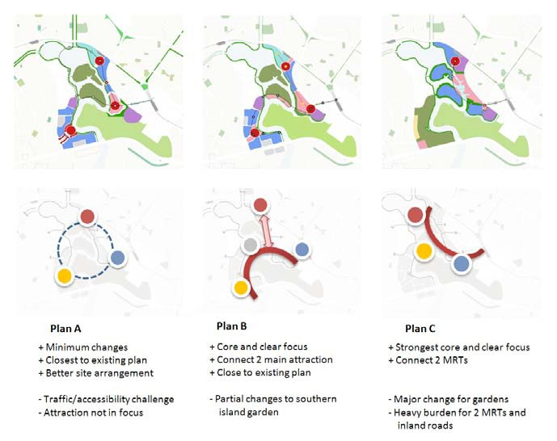Most land-use planning/design projects involve the creation of a number of alternative solutions, sometimes called scenarios. These scenarios, of which there can be many (2 or 3 on the low end and 50 to 60 on the high end), can be based on differing assumptions regarding performance requirements; design concepts; the deployment of different design strategies; and any number of other condi- tions, which are often difficult to define.

An example of three alternative plans shown as A, B, and C along with their explanation. (Figure
© 2011 AECOM. All Rights Reserved)

What is really needed is a dashboard authoring environment.

While there are workarounds, scenario management is not directly supported by most GIS software programs.

Scenarios can be distinctively different or merely variations on a theme. Either way, they must be properly referenced (so they can be uniquely identified), stored, shared, compared (both graphically and parametrically), revised, and compared again.

Additionally, designers often take, or would like to take, one element (or set of elements) from one scenario and combine that with an element (or set of ele- ments) from another scenario to provide the seed for creating a third scenario.

These tools need to support all aspects of scenario management, including the creation of scenarios and how they are referenced, stored, retrieved, compared, revised, including how portions of one scenario can be combined with portions of another scenario to create a third scenario.

Most planning/design projects
– particularly those involving multiple disciplines – require collaboration beyond the simple share-review-comment workflow typically supported by document management systems.
While there are workarounds, scenario management is not directly supported by most GIS software programs. This is due to the fact that most GIS programs have focused on the management of geospatial data and on the analysis of that data but not on the use of that same geoprocessing environment for designing land-use (or land management) plans. The advent of geodesign thinking now challenges GIS with a new set of requirements for supporting the design (geode- sign) process.

Scenario management tools need to be developed to facilitate the creation and management of alternative geodesign scenarios. These tools need to support
all aspects of scenario management, including the creation of scenarios and how they are referenced, stored, retrieved, compared, revised, including how portions of one scenario can be combined with portions of another scenario to create a third scenario. The system also needs to manage version control, keeping track
of not only the various versions and their variations but also when and why they were created, and who created them.

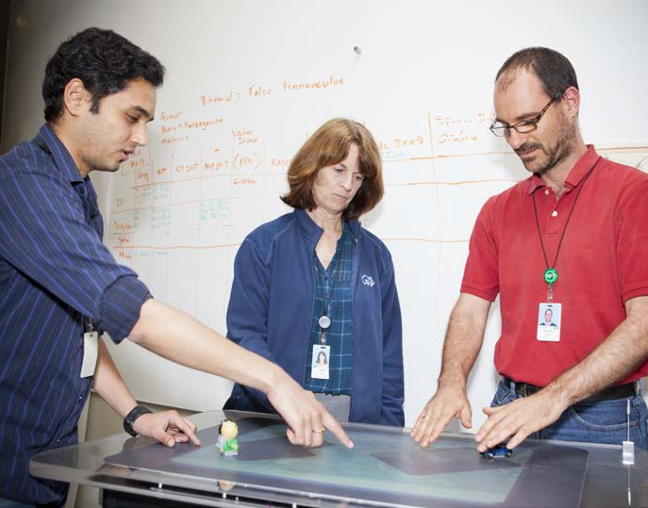

Collaboration Tools

Collaboration forms the conceptual basis for working with a team, most particu- larly during the accumulation of intellectual capital, the application of that capital to the assessment of conditions, and how those conditions affect the creation of something. It also provides the operational context for co-creating that some- thing (e.g., a land-use plan).

One can imagine a group of designers in a room together, with maps and draw- ings spread over a large table, surrounded by whiteboards filled with concept diagrams, the designers making notes and referencing information on personal digital devices or making notes on paper as they wait to take turns at the white- board or presenting their ideas using digital media. Events like this occur all the time in the lives of designers.
The difficulty resides in one’s ability to replicate this bricks-and-mortar environ- ment in digital space where space is distributed and time is not always syn- chronous. Most planning/design projects – particularly those involving multiple disciplines – require collaboration beyond the simple share-review-comment workflow typically supported by document management systems. Creative collaboration typically involves exploration, creation, assessment, modification, presentation, and documentation of alternate design scenarios in both shared and distributed space and in both synchronous and asynchronous time.

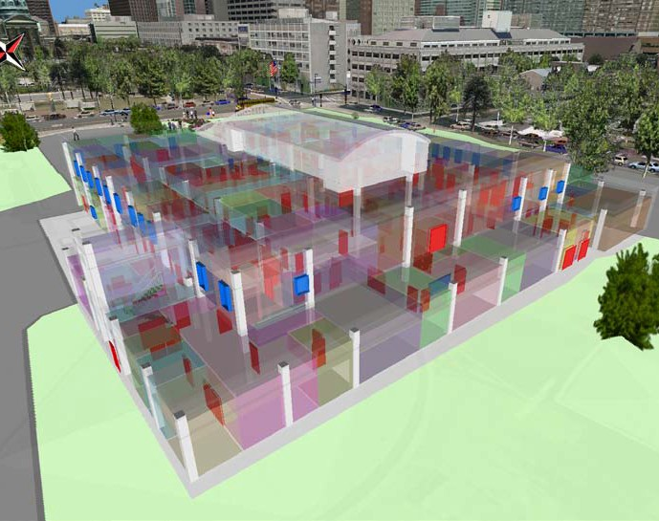Interoperability Tools

Geodesign is a broad field involving many different types of professionals (scientists, planners, architects, landscape architects, engineers, agency repre- sentatives, constructors, sponsors, stakeholders, etc.) working in many different domains (the list being too long to enumerate). Given this wide spectrum of pro- fessional activity, there is a correspondingly large number of software programs supporting that activity, each domain having its own cluster of software tools supporting various aspects of the design process.
The ability of these various tools (software programs) to conveniently talk to each other can be problematic and time- consuming, often requiring
the advanced skills of a highly qualified data gymnast to make it all work.

The ability of these various tools (software programs) to conveniently talk to each other can be problematic and time-consuming, often requiring the advanced
skills of a highly qualified data gymnast to make it all work. The impedance associ- ated with interoperability issues severely inhibits the work of designers and to this day stands as one of the more significant barriers to the overall design process.

One of the current approaches to interoperability is the use of third-party interoperability tools. While this approach provides a solution (when it works), it requires the use of yet another program, which in and of itself can create enough impedance to inhibit the design process.

Designers need transparent interoperability. They need the ability to simply transfer data created in one program into another program without having to do anything. This would be akin to doing projections on the fly. A few years ago GIS, analysts would have to explicitly convert their data from one projection to another. Today, translating from one projection to another is typically done on-the-fly as needed. The same type of behind-the-scenes transparency is needed as designers move data from one program to another.
The challenge to both the developers and appliers of geodesign technology is to understand the nature and importance of each of these characteristics, viewed individually, and how each relates to the other as integral components of a com- prehensive geodesign support system.

The future of geodesign depends on the collective understanding of the importance of design, an overall understanding of geodesign and what it means to design in the context of geographic space.

Creating the Future

The future of geodesign depends on the collective understanding of the impor- tance of design, an overall understanding of geodesign and what it means to design in the context of geographic space, a clear understanding of the nature of design and how designers work, and a concerted commitment to develop design-centric (designer-friendly) technologies and workflows supporting all aspects of the design/geodesign process.

This leads to four challenges:

Challenge 1 – Develop a comprehensive understanding of geodesign.

While this paper attempts to lay the groundwork for the development of a shared understanding of geodesign, it is neither comprehensive not does it represent
a shared vision. At best, it serves as a catalyst for further discussion and under- standing. In this sense, The author expects the responses to this paper to serve the greater geodesign community more than the paper itself. The challenge is to carry this conversation forward and work together to translate respective under- standings of what is meant by geodesign into a share vision.

Challenge 2 – Develop a design-centric GIS technology.

Perhaps the greatest challenge resides in the capacity of the software develop- ment community to absorb and assimilate the unique characteristics (needs) of geodesign and the somewhat idiosyncratic nature of the designer. The pro- grammer’s challenge is to create digital frameworks and functionality that truly facilitate the design/geodesign process. This is no small challenge, especially when one considers the designer’s desire for zero impedance. The idea of writ- ing design-centric software that is so easy to use that the use of that software is unnoticeable lies beyond the imagination of most programmers, notwithstand- ing the possible exception of those responsible for the development of Apple’s iPhone® or iPad®.

Challenge 3 – Apply that technology to a wide variety of geospatial design problems.

The success of this work to instantiate geodesign as a credible way of think- ing, as an advantageous way to do geospatial design, or as a way to design in geographic space will come from the repeated application of what is now known about geodesign using the tools that are now available (however limited they may be for the moment) to real-world problems. Applying knowledge will help
designers learn what works, what doesn’t, and what needs to be done to improve the capability to design in the context of geographic space and, in so doing, leverage the science and values co-referenced to that space. The dissemination
of this learning through these varied applications will serve to enhance the capac- ity to improve the quality of work and the vitality of those served by the work.

Challenge 4 – Establish a discipline of geodesign, both in practice and in academia.

Finally, there is a challenge to move beyond the geodesign catchphrase and associated rhetoric to establish a discipline of substance, including values, semantic clarity, and clearly defined processes that can be taught within the context of the various curricula offered by academic institutions and instantiated in professions. While geodesign may or may not become a singular profession, such as architecture or landscape architecture (many argue that it should not), it will surely (or perhaps, hopefully) find its way into the way people design the vari- ous entities that affect lives and, in some cases, the very life of the planet.

Regarding the future of geodesign, it is as Abraham Lincoln, Buckminster Fuller, Alan Kay, and Peter Drucker all said, “The best way to predict the future is to create it.”

The best way to predict the future is to create it

Bibliography

Capra, F. The Web of Life. Anchor Books, 1996.

Chrisman, N. Charting the Unknown: How Computer Mapping at Harvard
Became GIS. Esri Press, 2006.

Ervin, S. “A System for GeoDesign.” In: Proceedings of Digital Landscape
Architecture, Anhalt University of Applied Science, 2011.

Flaxman, M. “Fundamentals of Geodesign.” In: Proceedings of Digital Landscape
Architecture, Anhalt University of Applied Science, 2010.

Goodchild, M., D. Maguire, and D. Rhind. Geographic Information Systems: Principles and Applications (2 Vol.), Longman, 1991.

Kunzmann, K. “Geodesign: Chance oder Gefahr?” In: Planungskartographie und Geodesign. Hrsg.: Bundesforschungsanstalt für Landeskunde und Raumordnung. In-formationen zur Raumentwicklung, Heft 7, 1993.

Longley, P., M. Goodchild, D. Maguire, and D. Rhind. Geographic Information
Systems and Science. John Wiley & Sons, 2005. McHarg, I. Design with Nature. Doubleday & Co., 1969. McHarg, I. A Quest for Life. John Wiley & Sons, 1996.
Miller, G. ”The Magic Number Seven, Plus or Minus Two.” The Psychological
Review, 1956.
Miller, W. “Definition of Design.” Trimtab, Buckminster Fuller Institute, 2005. Miller, W. “Landscape Architecture: Education & Virtual Learning Environments.”
In: Proceedings of Trends in Online Landscape Architecture, Anhalt University,
2004.

Miller, W. Personal recollection. 2011

Miller, W. “Purpose of Design.” Trimtab, Buckminster Fuller Institute, 2006. Neutra, R. Survival Through Design. Oxford University Press, 1954.
Steinitz, C. “A Framework for Landscape Planning Practice and Education.”
Process Architecture, no. 127, 1995.

Steinitz, C. A Framework for Geodesign. Esri Press, to be published in 2012. Toker, F. Fallingwater Rising. Alfred A. Knopf, 2005.

Quotes

Drucker, P. “The best way to predict the future is to create it.”
www.brainyquote.com

Fuller, B. “The best way to predict the future us to design it.”
www.thegreenspotlight.com

Kay, A. “The best way to predict the future is to invent it.”
www.smalltalk.org

Lincoln, A. “The best way to predict your future is to create it.”
www.goodreads.com

Additional Resources

Artz, Matt. “Geodesign: A Bibliography,” Science and Design (blog), August 13, 2009
http://gisandscience.com/2009/08/13/geodesign-a-bibliography

Harvard bio, Professor Howard Taylor Fisher,
http://www.gis.dce.harvard.edu/fisher/HTFisher.htm

McElvaney, Shannon, “Geodesign for Regional and Urban Planning,” Esri Press, to be published in 2012.

Miller, William R., “Definition of Design,” February 11, 2004,
http://www.wrmdesign.com/Philosophy/Documents/DefinitionDesign.htm

Miller, William R., “Purpose of Design,” July 28, 2004,
http://www.wrmdesign.com/Philosophy/Documents/PurposeDesign.htm

NCGIA home page, http://www.ncgia.ucsb.edu

NCGIA, “Carl Steinitz,”
http://www.ncgia.ucsb.edu/projects/scdg/docs/cv/Steinitz-cv.pdf

Wikipedia, s.v. “Frank Lloyd Wright”, accessed November 22, 2011,
http://en.wikipedia.org/wiki/Frank_Lloyd_Wright

Wikipedia, s.v. “Geodesign,” accessed November 22, 2011,
http://en.wikipedia.org/wiki/Geodesign

Wikipedia, s.v. “Ian McHarg,” accessed November 22, 2011,
http://en.wikipedia.org/wiki/Ian_McHarg

Wikipedia, s.v. “Jack Dangermond,” accessed November 22, 2011
http://en.wikipedia.org/wiki/Jack_Dangermond

Wikipedia, s.v. “Michael Goodchild”, accessed November 22, 2011,
http://en.wikipedia.org/wiki/Michael_Frank_Goodchild

Wikipedia, s.v. “Richard Neutra,” accessed November 22, 2011,
http://en.wikipedia.org/wiki/Richard_Neutra

Wikipedia, s.v. “Warren H. Manning,” accessed November 22, 2011,
http://en.wikipedia.org/wiki/Warren_H._Manning

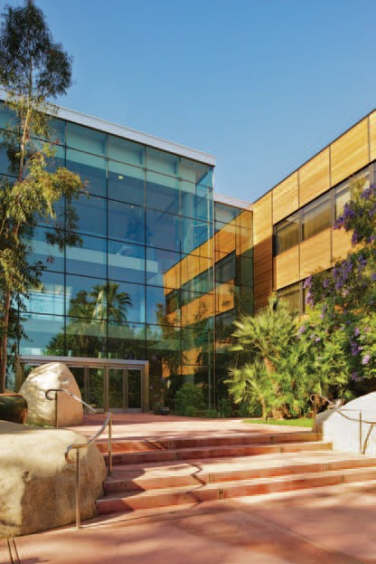Esri inspires and enables people to positively impact their future through a deeper, geographic understanding of the changing world around them.

Governments, industry leaders, academics, and nongovernmental organizations trust us to connect them with the analytic knowledge they need to make the critical decisions that shape the planet. For more than 40 years, Esri has cultivated collaborative relationships with partners who share our commitment to solving earth’s most pressing challenges with geographic expertise and rational resolve. Today, we believe that geography is at the heart of a more resilient and sustainable future. Creating responsible products and solutions drives our passion for improving quality of life everywhere.

Contact Esri

380 New York Street
Redlands, California 92373-8100 usa

1 800 447 9778 t 909 793 2853 f 909 793 5953 info@esri.com esri.com

Offices worldwide
esri.com/locations

Copyright © 2012 Esri. All rights reserved. Esri, the Esri globe logo, ArcGIS, ArcSketch, ArcMap, ArcInfo,
@esri.com, and esri.com are trademarks, service marks, or registered marks of Esri in the United States, the European Community, or certain other jurisdictions. Other companies and products or services mentioned herein may be trademarks, service marks, or registered marks of their respective mark owners.

Printed in USA
131511
ESRI7/12dh

